**DNS server configuration in Packet Tracer**

A Domain Name System (**DNS**) server resolves host names into IP addresses. Although we can access a network host using its IP address, DNS makes it easier by allowing us use domain names which are easier to remember. For example it’s much easier to access google website by typing [http://www.google.com](http://www.google.com/) as compared to typing [http://208.117.229.214](http://208.117.229.214/). In either case, you’ll access Google website, but using domain name is obviously easier.

Now, before any host can use a DNS service, we must configure a DNS server first. For example, when you type the URL [http://www.google.com](http://www.google.com/) in your browser, the host will query the DNS server for the IP address of [http://www.google.com](http://www.google.com/). The DNS server will resolve [http://www.google.com](http://www.google.com/) into an IP address then answer back the host with the IP address.

Now let’s configure a DNS server in Packet Tracer.

1. Build the network topology.

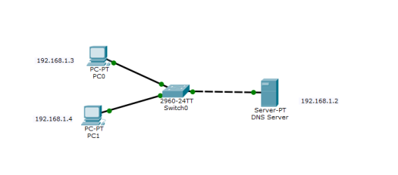

2. Configure static IP addresses on the PCs and the server.

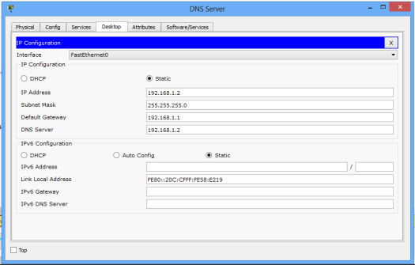

**Server**

**IP address**: 192.168.1.2   **Subnet mask**: 255.255.255.0  **Default gateway:** 192.168.1.1  **DNS Server**: 192.168.1.2

**PC0**

**IP add:**192.168.1.3    **Subnet mask:** 255.255.255.0  **Default gateway:** 192.168.1.1 **DNS server:**192.168.1.2

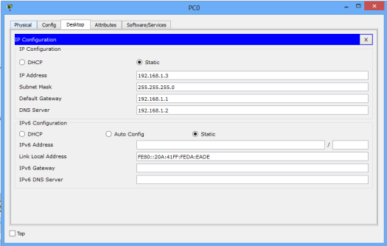

**PC1**

**IP address:**192.168.1.4  **Subnet mask:**  255.255.255.0  **Default gateway:**192.168.1.1  **DNS** **Server:** 192.168.1.2

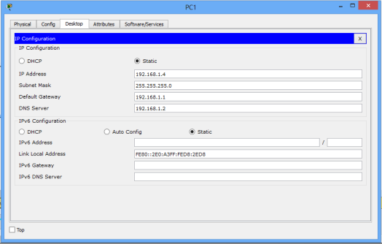

**3. Configure DNS service on the generic server.**

To do this, click on the server, then Click on**Services**tab. Click on **DNS server** from the menu. First turn **ON** the DNS service, then define **names** of the hosts and their corresponding **IP addresses.**

For example, to specify the DNS entry for PC0: In the**name**and **address**fields, type:

**Name:** PC0     **Address:**192.168.1.3

Click on **add**then **save**. Repeat this for the PC1 and the server.

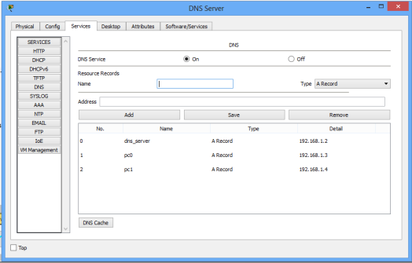Once you’re done, your DNS entries will look like this:

4. Test **domain name – IP resolution**. Ping the hosts from one another using their names instead of their IP addresses. If the DNS service is turned on and all IP configurations are okay, then ping should work.

For example, ping PC1 from PC0. Ping should be successful.

